Problem no : 01 (Nested for loop)
#include <stdio.h>s
int main ()
{
int row ,col,n;
printf("Enter the value");
scanf("%d",&n);
for (row=1;row<=n;row++){
for (col=1;col<=row;col++){
printf("%d",col);
}
printf("\n");
}
return 0;
}
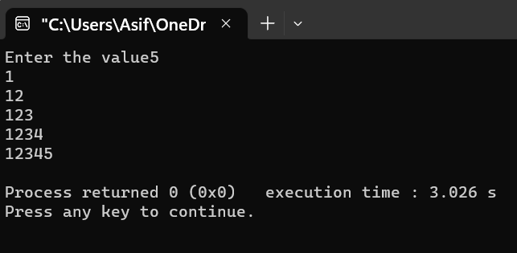
Descripsion: I use nested for loop

Problem no : 02
#include <stdio.h>
int main ()
{
int row ,col,n;
printf("Enter the value");
scanf("%d",&n);
for (row=1;row<=n;row++){
for (col=1;col<=row;col++){
printf("%d",row);
}
printf("\n");
}
return 0;
}
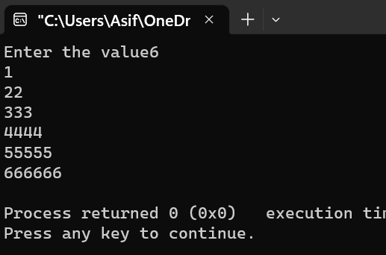

Problem no :03
#include <stdio.h>
int main ()
{
int row ,col,n;
printf("Enter the value");
scanf("%d",&n);
for (row=1;row<=n;row++){
for (col=1;col<=row;col++){
printf("*");
}
printf("\n");
}
return 0;
}
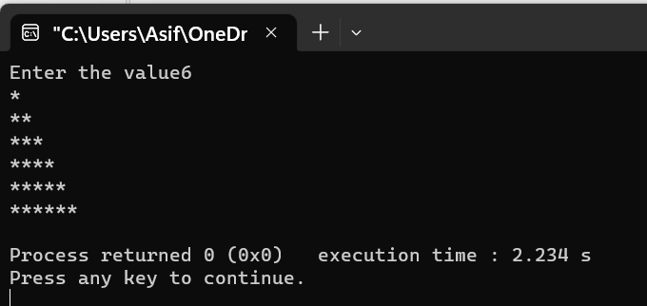

Problem no :04
#include <stdio.h>
int main ()
{
char row ,col,n;
printf("Enter the value");
scanf("%d",&n);
for (row=1;row<=n;row++){
for (col=1;col<=row;col++){
printf("%c",col+64);
}
printf("\n");
}
return 0;
}
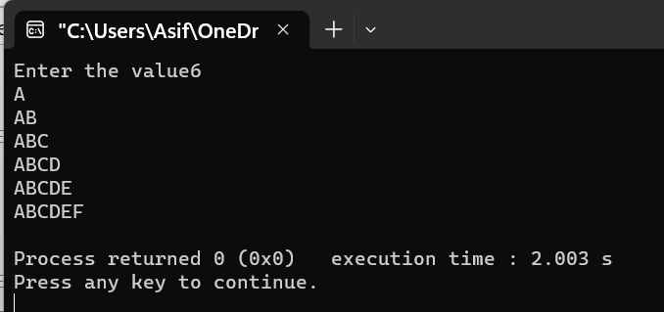

Problem no :05
#include <stdio.h>
int main ()
{
char row ,col,n;
printf("Enter the value");
scanf("%d",&n);
for (row=1;row<=n;row++){
for (col=1;col<=row;col++){
printf("%c",col+96);
}
printf("\n");
}
return 0;
}
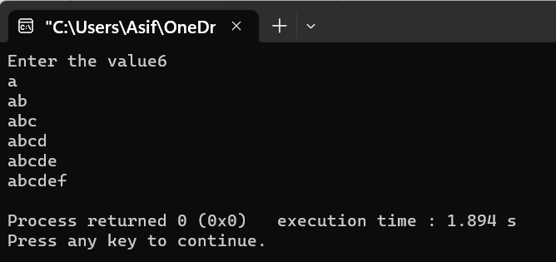

Problem no: 06
#include <stdio.h>
int main ()
{
int row ,col,n;
printf("Enter the value");
scanf("%d",&n);
for (row=1;row<=n;row++){
for (col=1;col<=row;col++){
printf("%d",col%2);
}
printf("\n");
}
return 0;
}
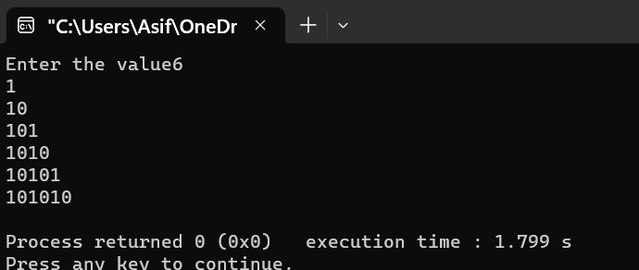

Problem no :07
#include <stdio.h>
int main() {
int i, space, rows, k = 0;
printf("Enter the number of rows: ");
scanf("%d", &rows);
for (i = 1; i <= rows; ++i, k = 0) {
for (space = 1; space <= rows - i; ++space) {
printf(" ");}
while (k != 2 * i - 1) {
printf("* ");
++k;}
printf("\n");}
return 0;
}
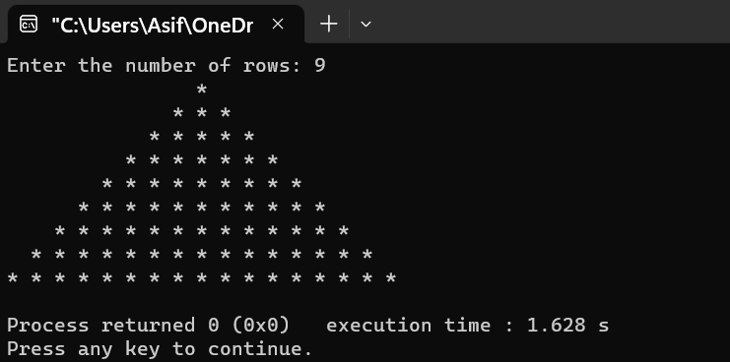

Problem no :08 (find cube of any number using function)
int main ()
{
int num1,result;
lavel:printf("Enter the value :");
scanf("%d",&num1);

result=cube(num1);
printf("cube=%d\n",result);
goto lavel;
return 0;
}
int cube(int a)
{
return a*a*a;
}

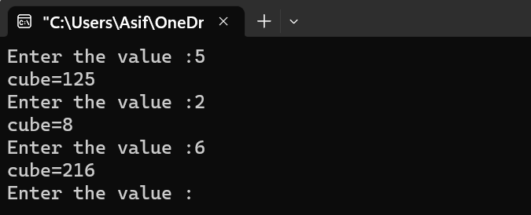

Problem no: 09 (find sum of any number suing function)
#include <stdio.h>
int main ()
{
int num1,num2;
printf("Enter the value :");
scanf("%d%d",&num1,&num2);

printf("sum=%d",sum(num1,num2));
return 0;
}
int sum (int a,int b)
{
return a+b;
}

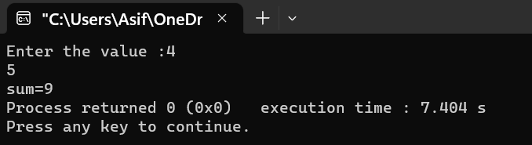

Bangladesh University of Business & Technology



Lab Report: 06
Course Title: Structured Programming Language Lab
Code: CSE-112

Submitted By | Submitted To
Name: Rakibul islam asif  ID:22235103319  Intake:51, Section:8  Department of CSE | Name: Md. Saddam Hossain.  Assistant Professor  Department of CSE BUBT

Submission Date: 16-03-2023

